A

REPORT

ON

**MATHEMATICAL MODELING & CONROLLER DESIGN FOR INVERTED PENDULUM**

*Submitted in partial fulfillment of the requirements for*

**SUMMER RESEARCH INTERNSHIP**

**(ELECTRICAL ENGINEERING)**

By

**DEEPESHWAR KUMAR**

(U15EE054)

**: Supervisor:**

**DR. SHAMBHU N. SHARMA**



**DEPARTMENT OF ELECTRICAL ENGINEERING**

**SARDAR VALLABHBHAI NATIONAL INSTITUTE OF TECHNOLOGY**

**SURAT – 395007**

**2017 – 2018.**

|  |
| --- |
| **EXAMINERS APPROVAL CERTIFICATE**  **SUMMER INTERNSHIP 2017 - PRESENTATION** |

This is to certify that the Summer research Internship 2017 Report Entitled ***“Mathematical Modeling & Controller Design of Inverted Pendulum”*** submitted by **Mr. DEEPESHWAR KUMAR (U15EE054)** under the supervision of **Dr. S. N. Sharma** of S. V. National Institute of Technology Surat is hereby approved.

The presentation made by the student in front of the following Evaluation Team is found satisfactory.

|  |  |  |  |
| --- | --- | --- | --- |
| **Dr. S. N. Sharma**  (Supervisor)  Assosiate Professor,  Department of Electrical  Engineering  SVNIT, Surat | **Dr. M. A. Mulla Dr. Kundu Prashanta**  (Examiner) (Examiner)  Assosiate Professor Assistant Professor  Department of Electrical Department of Electrical  Engineering Engineering  SVNIT, Surat SVNIT, Surat | | |
|  | | |  |

|  |  |
| --- | --- |
|  |  |
|  |  |

# ACKNOWLEDGMENT

I would like to express my deep sense of gratitude to my guide **Dr. S. N. Sharma(EED, SVNIT, SURAT)** for his valuable technical guidance, motivation and for his extreme cooperation to complete my project work. He has given me enough freedom during my research, and he has always been nice to me. I will always remember his calm and relaxed nature.

I would like to express my sincere respect and profound gratitude to **Mr. Jitendra Singh(Mtech II, EE)** for supporting and providing the facilities for my project work.

I appreciate throughout support of **Yash Patil(B.Tech 3rd year,ME) ,Rishabh Jain(B.Tech 3rd year,ME)** andall colleagues whose direct and indirect contribution helped me a lot to accomplish this report. I would also like to thank all the teaching and non-teaching staffs for cooperating with me and providing valuable advice which helped me in the completion of this work.

Finally, I would like to express my thanks to all the members of my lovely family, without whose support I would have never been able to aspire for this level of education.

* **Deepeshwar Kumar**

# ABSTRACT

Stabilization of Inverted Pendulum is defined as a very basic classical control problem in Control System. The Dynamics of Cart Inverted Pendulum is related to many real life applications like missile launching system, balancing systems like human walking, Aircraft landing pad in sea etc. This is a highly Unstable and non-linear system. This system is a under actuated system and also a non-minimum phase system so design a Controller for Inverted Pendulum System is very complex.

This report includes system and hardware description of Inverted Pendulum System, Dynamics of the system, Derivation of Transfer Functions, details of the analysis of uncompensated design. Also we have explains the possible ways of designing the required control system for the inverted pendulum system in which we have provided details analysis of the lag – lead compensated system for closed loop system. And the other way is state space model of the inverted pendulum system in which we have analyze the full state feedback in the simulation. We have also includes the practical results obtained from the hardware setup of the inverted pendulum system using Arduino mega controller and the PID controller used for control the angular position in upward direction for hardware setup.

# TABLE OF CONTENT

CERTIFICATE i

EXAMINERS APPROVAL CERTIFICATE ii

ACKNOWLEDGMENT iii

ABSTRACT iv

TABLE OF CONTENT v

LIST OF FIGURE viii

LIST OF TABLE x

NOMENCLATURE xi

LIST OF ACRONYMS xii

CHAPTER1: Introduction to the Inverted Pendulum 1

1.1 Introduction 1

1.2 Background of the IP 3

1.3 Application of IP 4

1.4 Report Contribution 5

1.5 Report Outline 5

CHAPTER2: Mathematical Model for IP 6

2.1 Equation of Motion using Lagrange’s Equation 6

2.2 Linearization 9

2.2.1 First by Approximation around Operating Point 9

2.2.2 State Space Model:(Linearization using Taylor Series Expansion) 10

CHAPTER3: System Analysis 16

3.1 Analysis of Nonlinear Model of IP 16

3.2 Analysis of Linear Model of IP 18

3.2.1 Open-loop Impulse Response of the System 19

3.2.2 Open-loop step response of the system 20

3.3 Linear State-space Model simulation in open loop 20

3.4 Stability Test 22

3.5 Controllability of the system 23

CHAPTER4: Controller Design 24

4.1 Controller Design specification 24

4.2 Compensation design 25

4.2.1 Why Root Locus? 26

4.2.2 Root Locus of Uncompensated System 27

4.2.3 Necessity of the Integrator 28

4.2.4 Lead-Lag Compensator Design 29

4.2.5 Simulation of Compensated System 30

4.3 Full State Feedback Design 32

4.3.1 Achieving Stability by Pole placement method 33

CHAPTER5: Experimental Determination 37

5.1 Hardware Setup Explanation 37

5.1.1 Body 38

5.1.2 Controller 38

5.1.3 Drive Systems 38

5.1.4 Encoders 39

5.2 Controller: Classical PID Controller 40

5.3 Discussion of Hardware Result 42

CHAPTER6: CONCLUSION & FURTHER WORK 44

REFERENCE LIST 45

# LIST OF FIGURE

Figure 1‑1 Schematic of Inverted Pendulum 1

Figure 1‑2 Basic Idea for Controlling Inverted Pendulum System 2

Figure 2‑1 Free Body Diagram of Inverted Pendulum 6

Figure 3‑1 Simulation of Nonlinear model of IP 17

Figure 3‑2 Step Response of Nonlinear Model of IP 17

Figure 3‑3 3D Visualization of IP in VRML 18

Figure 3‑4 Impulse Response of Linear transfer function 19

Figure 3‑5 Step Response of Linear transfer function 20

Figure 3‑6 Simulation of State Space Model in open loop 21

Figure 3‑7 Step Response of Linear State Space Model in Open Loop 21

Figure 3‑8 Pole-Zero map of System Transfer function 23

Figure 4‑1 Dominant poles placement for design specification 25

Figure 4‑2 Root locus for uncompensated system 27

Figure 4‑3 Shape of root locus after adding a integrator in the system 28

Figure 4‑4 Root locus of compensated system 29

Figure 4‑5 Simulation for step response of compensated system 30

Figure 4‑6 Step Response of Compensated system 31

Figure 4‑7 Impulse Response of compensated system 31

Figure 4‑8 Impulse Response of compensated system 32

Figure 4‑9 Full state feedback controller schematic 32

Figure 4‑10 Simulation for Full state feedback using Pole Placement 34

Figure 4‑11 Step Response using pole placement – 1st test 35

Figure 4‑12 Step Response using pole placement – 2nd test 35

Figure 4‑13 Step Response using pole placement – 3rd test 36

Figure 5‑1 Image of hardware setup of Inverted Pendulum 37

Figure 5‑2 Image of Motor and Motor driver 39

Figure 5‑3 Image of quadrature Encoder 40

Figure 5‑4 Block diagram of Control scheme with PID controller 40

Figure 5‑5 PID Response of angular position 42

# LIST OF TABLE

Table 1 Nomenclature xi

Table 2 List of Abbreviation xii

Table 3 Useful Matlab commands xii

Table 4 Motor specification 38

# NOMENCLATURE

Table 1 Nomenclature

|  |  |  |  |
| --- | --- | --- | --- |
| **Symbol** | **Description** | **Value** | **Unit** |
| M | Mass of the Cart | 0.4 | kg |
| m | Mass of the Bob of Pendulum | 0.1 | kg |
| l | Length of the Rod | 0.6 | m |
| L | Length of the track | 2 | m |
| b | Friction constant of the Cart | 0.1 | N*sec/m |
| g | Gravitational constant | 9.8 | m/sec2 |
| F | Force | - | N |
| x | Cart’s position | - | m |
|  | Angle deviation between Pendulum & Vertical’s axis | - | radian |

# LIST OF ACRONYMS

Table 2 List of Abbreviation

|  |  |
| --- | --- |
| **Abbreviation** | **Description** |
| IP | Inverted Pendulum |
| SIMO | Single-Input-Multi-Output |
| PID | Proportional Integral Derivative |
| DOF | Degrees Of Freedom |
| ISR | Interrupt Service Routine |
| SISO | Single-Input-Single-Output |
| MATLAB | Matrix Laboratory |
| PWM | Pulse width modulation |

Table 3 Useful Matlab commands

|  |  |
| --- | --- |
| Eig | Compute eigenvalues |
| Tf | Generates the transfer function LTI object |
| Bode | Draw a bode plot |
| Pole | Compute pole |
| place | Compute a pole placement feedback matrix |
| rlocus | Draw a rootlocus |
| sisotool | Analysis & control design for LTI object |
| Rank | Compute the rank of Matrix |
| Ctrl | Compute the controllability matrix |
| Pzmap | Plot the pole – zero map |

# Introduction to the Inverted Pendulum

*[This Chapter presents on historical study on Inverted Pendulum System, methods of control the Inverted Pendulum System. Technical requirement and different challenges related to Design the appropriate Controller for Inverted Pendulum.]*

## Introduction

The stabilization of inverted pendulum is a classical benchmark control problem. It is a simple system in terms of mechanical design only consisting of a D.C. Motor, a pendant type pendulum, a cart, and a driving mechanism. Fig.1.1.shows the basic schematic for the cart-inverted pendulum system

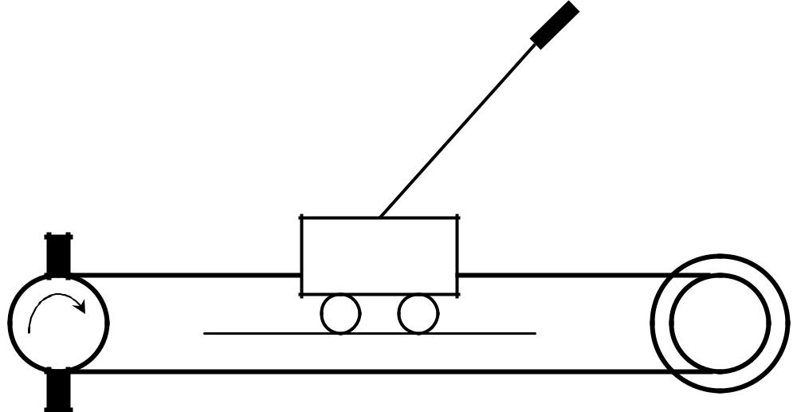

**Inverted Pendulum**

**Sprocket Wheel**

|  |  |
| --- | --- |
| **Toothed Belt** | **Cart** |

**D.C. Motor**

Figure 1‑1 Schematic of Inverted Pendulum

The Inverted Pendulum is a single input multi output (SIMO) system with control voltage as input, cart position and pendulum angle as outputs. The simplest form of an inverted pendulum consists of a mass attached through a massless rod to a base mass. This is commonly known as a cart-pendulum system. This system is shown in Figure 1.1. The cart is free to move horizontally. The rod is connected to the cart through a rotational pin joint. This system is in unstable equilibrium when the rod is standing upright. Mathematically, this equilibrium can be maintained as long as there are no input forces whatsoever on the system. However, such conditions do not exist in real systems and some means of stabilization is needed to maintain the pendulum in the upright position. A force F must be applied to the cart in order to move the cart pivot back and forth from one side of the pendulum mass center to the other side. The pendulum is always falling over, but the cart motion tries to keep the leaning angle at a small level. Given their unstable dynamics, inverted pendulums rarely occur in useful products. However, their dynamics and control have been well studied by engineers.

If the output is the angle of the pendulum relative to the vertical axis (in upright position), we realize that system is unstable, since the pendulum will fall down if we release it with a small angle. To stabilize the system, i.e., to keep the pendulum in upright position, a feedback control system must be used.

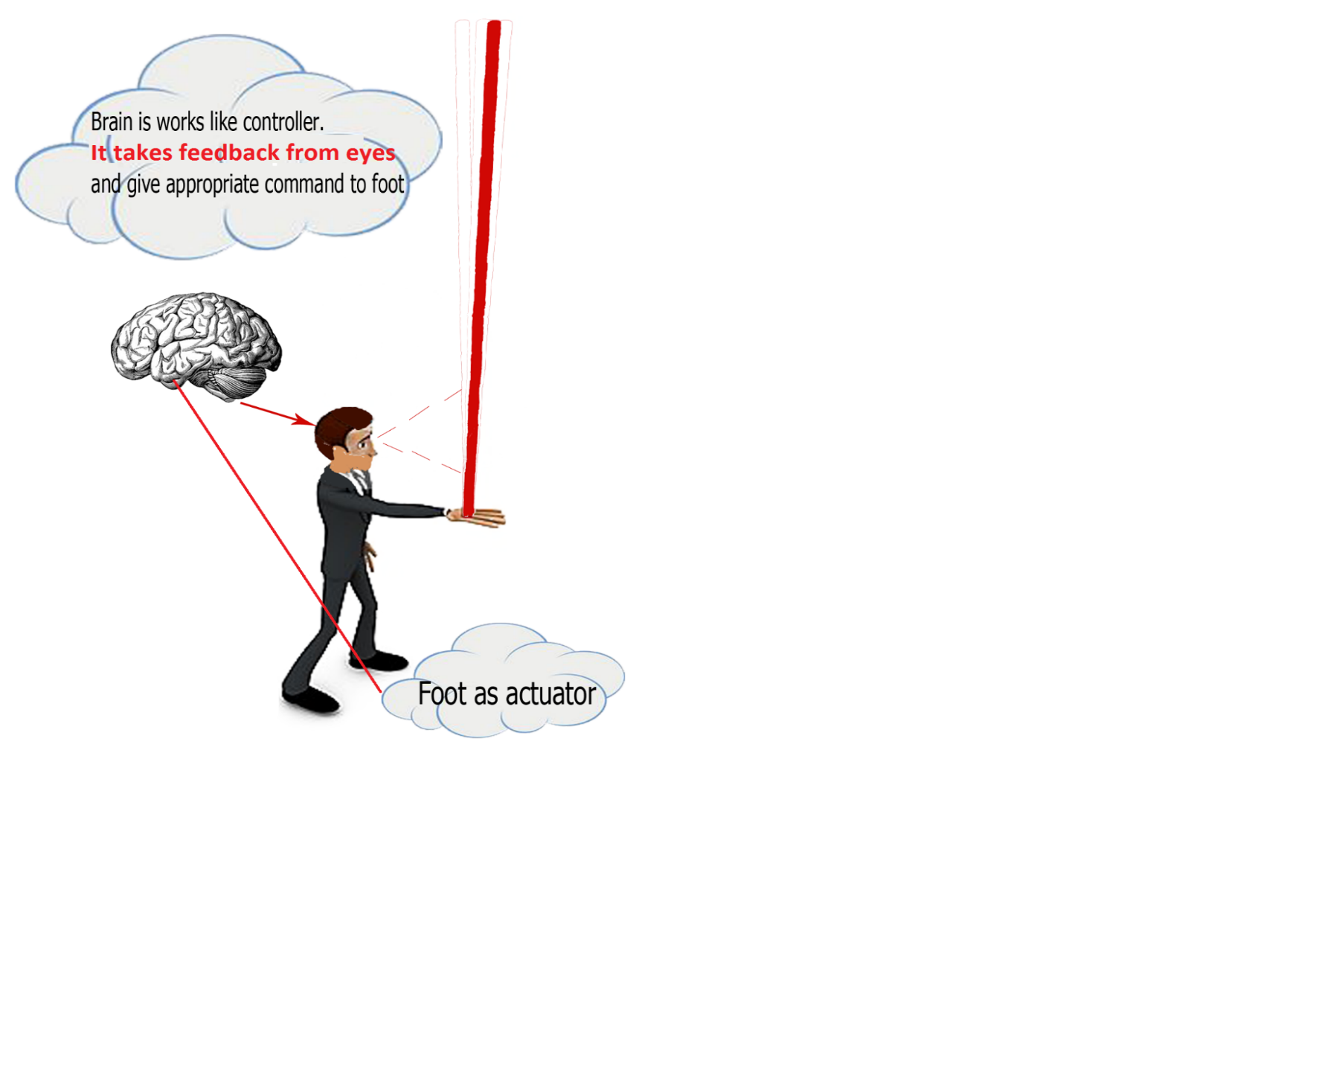

Figure 1‑2 Basic Idea for Controlling Inverted Pendulum System

when we were a child and we tried to balance a broom-stick on our index finger or the palm of our hand? we have to constantly adjust the position of our hand to keep the object upright. An INVERTED PENDULUM does basically the same thing. However, it is limited in that it only moves in one dimension, while your hand could move up, down, sideways, etc.

So what that man in the Fig.1.2 is trying to tell us. It’s nothing but he is trying to control an inherently unstable system through his body parts, sense organ and mind.

As he kept the boom-stick on his palm, his eyes will start visualizing the tilt angle of the stick from vertical reference. Now the sensory organ will send the data to the mind that will processed there for how to balance that stick on the palm. Now the mind will processed it and give the appropriate command/signal to the hand and legs so that he will adjust his position such that stick will never going to fall down from his palm. This explanation relates most difficult systems of the control engineering the basic human action in his life.

The *inverted pendulum* (IP) is among the most difficult systems to control in the field of control engineering. Due to its importance in the field of control engineering, it has been a task of choice to be assigned to Control Engineering students to analyze its model and propose a linear compensator according to the PID control law. It is a nonlinear system, which can be treated to be linear, without much error, for quite a wide range of variation.

The reasons for selecting the IP as the system are: ·

* It is the most easily available system (in most academia) for laboratory usage. ·
* It is a nonlinear system, which can be treated to be linear, without much error, for quite a wide range of variation.
* Provides a good practice for prospective control engineers.

## Background of the IP

The inverted pendulum is the classical control system problem. It has some concept like a hand as a cart and stick as a pendulum which is hand try balance the stick. In addition, the inverted pendulum have limited motion that only can move right and left meanwhile the hand which try to balance the stick has advantage can moving upward and downward. An inverted pendulum does basically the same thing. Just like the broom-stick, an inverted pendulum is an inherently unstable system. Force must be properly applied to keep the system intact. To achieve this, proper control theory is required.

The inverted pendulum is essential in the evaluating and comparing of various control theories. The inverted pendulum (IP) is among the most difficult systems to control in the field of control engineering. Due to its importance in the field of control engineering, it has been choose for summer research intern project to analyze its model and propose a linear compensator according to the PID control law.

In new era, the concept of inverted pendulum is become important in daily life especially in field control system. The concept stability that show in inverted pendulum can be apply in real life application for example the helicopter already use concept stability to reject windup disturbance and also the missile that moving faster without have problem due to the concept stability.

## Application of IP

There are many instances of the inverted pendulum model both man made and found in the natural world. Arguably the most prevalent example of an inverted pendulum is a [human being](https://en.wikipedia.org/wiki/Human_being). A person with an upright body needs to make adjustments constantly to maintain balance whether standing, walking, or running. Some simple examples include balancing brooms or meter sticks by hand. The inverted pendulum has been employed in various devices and trying to balance an inverted pendulum presents a unique engineering problem for researchers. The inverted pendulum was a central component in the design of several early [Seismometers](https://en.wikipedia.org/wiki/Seismometer) due to its inherent instability resulting in a measurable response to any disturbance. The inverted pendulum model has been used in some forms of personal transportation devices. Two-wheeled wheel chairs and other two wheeled motorized vehicles can offer enhanced mobility for the driver.

## Report Contribution

This thesis makes contribution to expend the understanding of the dynamics of Inverted Pendulum. The main contributions are:

1. A Mathematical model of Inverted Pendulum.
2. Linearization of Nonlinear IP by using Taylor series expansion (Jacobian Matrix) and drive the Linear state space model for the Inverted Pendulum system.
3. Analyzing the step and impulse response of Nonlinear & Linear model of IP in open loop.
4. Stability test for need of controller design.
5. Designing lag-lead compensator in classical control system.
6. Designing full state feedback controller by pole placement and LQR controller.
7. Hardware Implementation & Experimental Result Discussion.

## Report Outline

Chapter 2 starts by describing the mathematical modelling of Inverted pendulum system. Then, it describes the Linearization process for nonlinear model of IP. It then drive the state space model of IP system. Chapter 3 presents the analysis of nonlinear & linear IP model. It shows that the step response of linear system without controller is highly unstable. Chapter 4 presents the process of designing the appropriate controller for the IP system i.e. lag – lead compensator in classical control theory and full state feedback control in modern control theory. Finally Chapter 5 provide the experimental determination and discussion of practical results.

# Mathematical Model for IP

*[This chapter presents generalize Equation of motion of IP by using Lagrange’s Equation. The process of Linearization of Nonlinear model of IP and State Space Model study is carried out.]*

## Equation of Motion using Lagrange’s Equation

The free body diagram of Inverted Pendulum is shown in Fig.2.1, The mechanical system has Two Degree of freedom (DOF), the linear motion of cart in X-axis, the rotation motion of the pendulum in the X-Y plan. Thus there will be two dynamic equations.

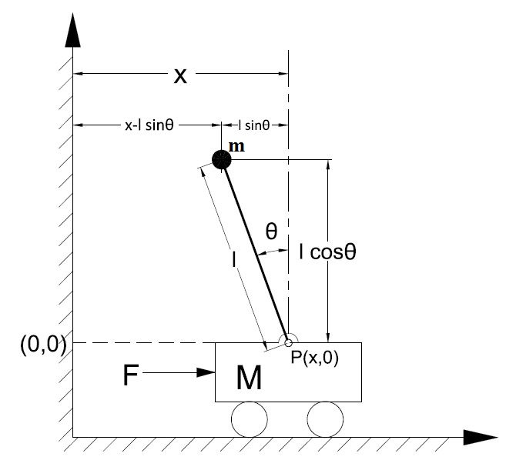

Figure 2‑1 Free Body Diagram of Inverted Pendulum

 The non-relativistic Lagrangian for a system of particles can be defined by

|  |  |
| --- | --- |
| L = T – V. | (2.1) |

where {\displaystyle L=T-V}{\displaystyle T={\frac {1}{2}}\sum _{k=1}^{N}m_{k}v_{k}^{2}}

|  |  |
| --- | --- |
| T = . | (2.2) |

‘L’ is the Lagrangian Function, ‘T’ is the total kinetic energy of the system, equating the sum Σ of the kinetic energies of the particles, and ‘*V*’ is the potential energy of the system.

The equations of motions can be derived by using Lagrange’s equations. Just refer the drawing to your right.

Given an inverted pendulum mounted on a motor-pulley driven cart, the defining nonlinear equations can be derived as follows. First we assume that the rod is massless and that the cart mass and the point mass at the upper end of the inverted pendulum are denoted as M and m, respectively. There is an externally X-directed force on the cart, , and a gravity force acts on the point mass all times. In the coordinate plane, represents the cart position and is the tilt angle referenced to the vertically upward direction. Here is the length of the rod.

The Lagrangian L = T – V of the system is:

|  |  |
| --- | --- |
| + . | (2.3) |
|  |  |

where  {\displaystyle v_{1}} is the velocity of the cart and {\displaystyle v_{2}} is the velocity of the point mass m. {\displaystyle m}and {\displaystyle v_{2}}and can be expressed in terms of x and  {\displaystyle \theta }by writing the velocity as the first derivative of the position;

has only one component in the x-direction

|  |  |
| --- | --- |
| . | (2.4) |
|  |  |

And has two component: in x-direction & in y-direction

|  |  |
| --- | --- |
| . | (2.5) |

Simplifying the expression for  {\displaystyle v_{2}} leads to:

|  |  |
| --- | --- |
| . | (2.6) |

Substituting the value of and from equations (2.5) and (2.6) respectively in equation (2.3) ,so the Lagrangian is now given by:

|  |  |
| --- | --- |
| + . | (2.7) |

Since system has 2DOF, so there are two Lagrangian equations of motion given below:- First equation shows the linear motion of cart which is driven by the force F and there is friction component opposes its motion where is the friction component. So the equation is:

|  |  |
| --- | --- |
| . | (2.8) |

Second equation shows the rotational motion of the pendulum, since it free to move in the 2-D plane so we can write it as:

|  |  |
| --- | --- |
| . | (2.9) |

substituting  {\displaystyle L} from eqn (1.7) in above two equations and simplifying leads to the equations that describe the motion of the inverted pendulum:

|  |  |
| --- | --- |
| .  . | (2.10)  (2.11) |

Eqn(2.10) and Eqn(2.11) are the dynamic of the inverted pendulum on cart system.

These equations definitely represent a nonlinear system which is relatively complicated from the mathematical point of view. However, since the goal of this particular system is to keep the inverted pendulum upright around one might consider linearization about the upright equilibrium point. We have done this in our next section.

## Linearization

The two equations (2.10) and (2.11) are non-linear and need to be linearized for the operating range.

So there are some methods to linearize your system equations. Let discuss here:

### First by Approximation around Operating Point

Since pendulum is being stabilized at an unstable equilibrium position, which is ‘Pi’ radian from the stable equilibrium position, this set of equations should be linearized about theta = 0. Assume that , (where represent a small angle from the vertical upward direction).

Therefore,

After linearization the two equations of motion become (where F represents the input):

|  |  |
| --- | --- |
| .  . | (2.12)  (2.13) |

To obtain the transfer function of the linearized system equations analytically, we must first take the Laplace transform of the system equations. The Laplace transforms are:

|  |  |
| --- | --- |
| .  . | (2.14)  (2.15) |

When finding the transfer function, initial conditions are assumed to be zero. The transfer function relates the variation from desired position [Output] to the force on the cart [Input].

Since we will be looking at the angle Phi as the output of interest, solve the first equation for X(s),

|  |  |
| --- | --- |
| . | (2.16) |

Then, by substituting the eqn (2.16) in the eqn (2.14), we get

.

Re-arranging, the transfer function is:

|  |  |
| --- | --- |
|  | (2.17) |

Putting the real values of the constants:

sec2

We have

|  |  |
| --- | --- |
|  | (2.18) |
|  |  |
|  |  |

Eqn(2.18) gives the Transfer Function between output angular position() and applied input Force(F).

### State Space Model:(Linearization using Taylor Series Expansion)

We have non-linear model as:

|  |  |
| --- | --- |
| . . | (2.10)  (2.11) |

Take the from eqn(2.11) , we have

|  |  |
| --- | --- |
|  | (2.18) |

Put the value in the eqn(2.10), we get

|  |  |
| --- | --- |
|  | (2.19) |

Similarly take from eqn (2.11) ,we have

.

Put the value of in the eqn (2.10), we get

|  |  |
| --- | --- |
|  | (2.20) |

Now to put these equations into state form, we make the following substitutions

|  |  |
| --- | --- |
| = | (2.21) |
|  |  |

So we can write and from eqn (20) and (19) as:

.

Thus we have final state space equations of inverted pendulum as:

|  |  |
| --- | --- |
|  | (2.22) |

If we desire a linearized system around the upright stationary point, we simply linearize the non-linear system given in the eqn(2.22).

We have a non-linear model

,

We want to find a “local”, linear model around an operating poin

Using Taylor Series expansion:

Assumptions:

And neglecting H.O.T

We have:

Re-define:

This leads to:

Where

So we can also linearize our non-linear model around a reference point:

Reference Point:

|  |  |
| --- | --- |
|  | (2.23) |

|  |  |
| --- | --- |
|  | (2.24) |

Putting the real values of the constants:

sec2

|  |  |
| --- | --- |
|  | (2.25) |

The **State Space Model** of IP system is obtained as Eqn(2.23) and Eqn(2.24).

# System Analysis

*[This Chapter focuses on the analysis of the Nonlinear IP system and analysis of linear system with various inputs in open loop, stability and controllability test perform in this chapter. The need of close loop controller for stable the unstable Linear IP system is describe in this chapter]*

## Analysis of Nonlinear Model of IP

In this section the inverted pendulum will be simulated without any feedback. This section will let you to understand the physical behavior of inverted pendulum when no feedback is applied.

We have simulate the non-linear model of IP in Simulink using Eqn(2.10) and Eqn(2.11). These two set of equations are:

. .

For understanding the physical behavior of the IP, we have build the physical model inverted pendulum on cart in the VRML and compare the animation and the graphs that are generated by the block states of Simulink model.

In Fig 3-1, We have numerically simulate the nonlinear model for the inverted pendulum equations of motion in the Simulink of the MATLAB. Here position of the cart and , the tilt angle of the inverted pendulum are taken as output of the system. Also they are plotted w.r.t to the time axis for studying the behavior of the nonlinear model of inverted pendulum.

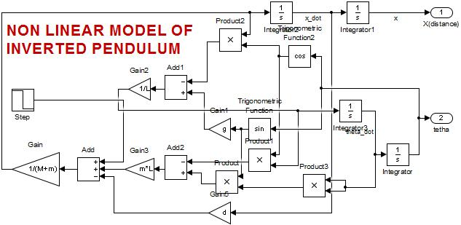

Figure 3‑1 Simulation of Nonlinear model of IP

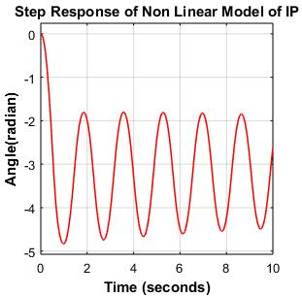 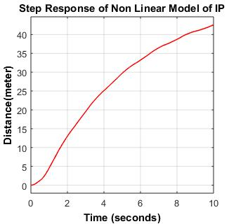

Figure 3‑2 Step Response of Nonlinear Model of IP

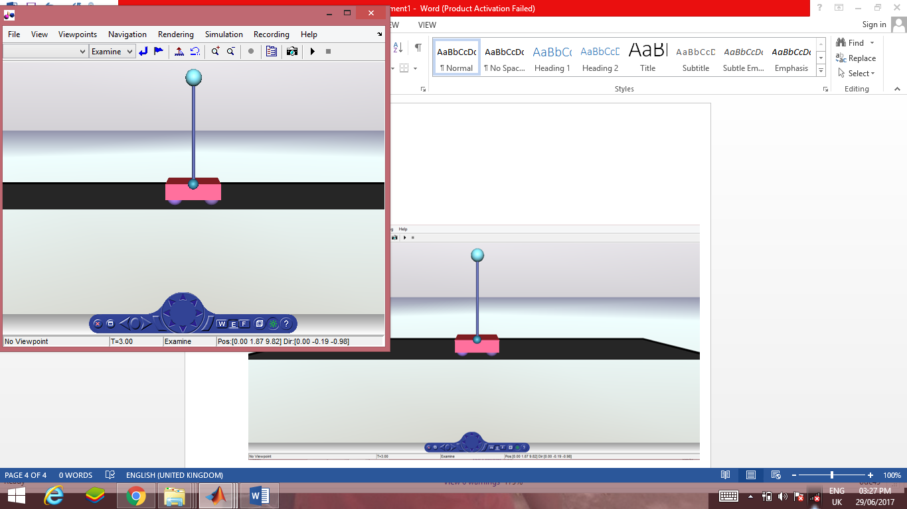

Figure 3‑3 3D Visualization of IP in VRML

A Step Response of the Non Linear model of the Inverted pendulum is shown in Fig 3-2, The system is highly unstable as theta() is oscillatory in nature and position of the cart diverges from the reference position very rapidly. This nature of responses indicates instability of the system. Hence system is highly unstable when the pendulum is at upside position(),therefore it is showing the need of controller for stable this system around operating point.

The behaviour of the system simulation, we can easily see in VRML that is associated with MATLAB simulink.

## Analysis of Linear Model of IP

The transfer function between angular position and applied input force is given by Eqn(2.18) as:

Step & impulse response of above transfer function can be analyzed using MATLAB command impulse() and step().

### Open-loop Impulse Response of the System

Examining on how the system responds of 1-N impulsive force applied to the cart, we have got the following result:

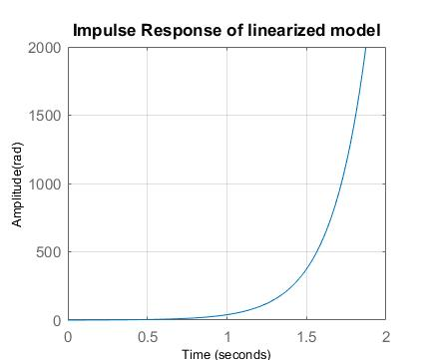

Figure 3‑4 Impulse Response of Linear transfer function

From Fig 3-4 the plot, the response is unsatisfactory. Both outputs never settle, the angle of the pendulum goes to several hundred radians in a clockwise direction though it should be less than 0.08726 rad. And the cart goes to the right infinitely. So, this system is unstable in an open loop condition when there is a small impulsive force applied to the cart.

### Open-loop step response of the system

Here also, it can be seen from the outputs that the system is unstable under 1-Newton step input applied to cart.

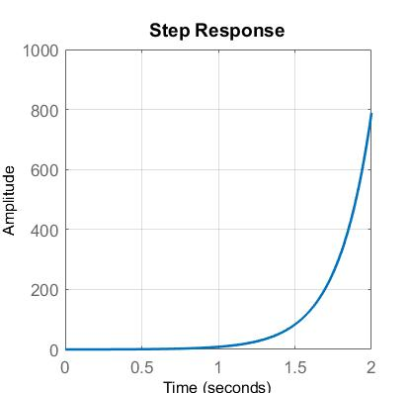

Figure 3‑5 Step Response of Linear transfer function

A step response of the system is shown in the Fig 3-5, Here also theta() diverges very rapidly as the system is highly unstable. The runaway nature of the response indicates instability.

## Linear State-space Model simulation in open loop

The linear state – space model is given by eqn(2.23) and eqn(2.24) as:

This is the standard LTI state-space form needed for implementation in MATLAB. In Fig 3-6, we simulate the open loop response of the linearized model of the inverted pendulum using Simulink.

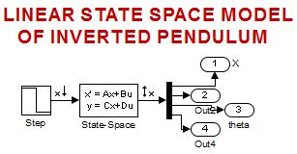

Figure 3‑6 Simulation of State Space Model in open loop

.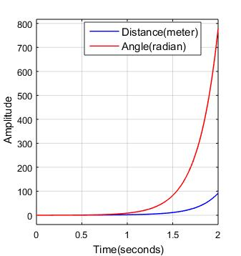

Figure 3‑7 Step Response of Linear State Space Model in Open Loop

Since from Fig 3-7, T0he system is unstable, only a short 2 seconds simulation is performed. With a step change in force, , on the cart, position of the cart increases rapidly and pendulum falls in the counterclockwise direction. The unstable open loop response of the inverted pendulum dictates the need for a robust control system to stabilize the pendulum and to improve the system response to set-point changes and to the disturbances in the system

## Stability Test

To check the stability means to analyze whether the open-loop system (without any feedback) is stable or not. That has partly done by the above simulations under the impulse and step forces. But as per the definition, the eigenvalues of the system state matrix, ‘A’, can determine the stability. That is equivalent to finding the poles of the transfer function of the system.

.

Where is the eigenvalue and is the eigenvector.

The eigenvalues tell us how the matrix A “acts” in different directions (eigenvectors).

The eigenvalues of the matrix are the values of s where A system is stable if real part of all its eigenvalues must be lied in the left- half of the s-plane such as negative number.

>> Poles =

. gives the eigenvalues of A matrix and we can observed that one of the eigenvalue is positive and in the right half of S-plane, Hence system is highly unstable.

We can also visualize these by pole-zero mapping of the system transfer function as below using MATLAB command.

System transfer function:

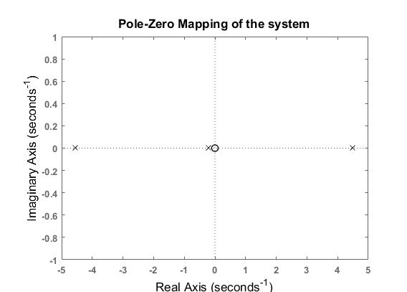

Figure 3‑8 Pole-Zero map of System Transfer function

It can be seen from the Fig 3-8,There is one pole on the right-half plane at. This confirms the intuition that the system is unstable in open loop. So we need to design a close loop controller to stabilize the given system.

## Controllability of the system

A system is controllable if there exists a control input that transfers any state of the system to zero in finite time. Also, the system is completely controllable if it is possible to go from any initial state to any final state. It can be shown that an LTI system is controllable if and only if its controllability matrix, CO, has full rank, i.e. if where is the number of states.

Controllability matrix

The system is completely controllable if and only if

Using the following MATLAB command, the controllability matrix of the system is:

So, since the controllability matrix has full rank, the system is controllable, Hence we can design full state feedback controller.

# Controller Design

*[This chapter includes the controller design schemes, Compensator design using classical control theory and Full state feedback design using Modern control theory are illustrated, the basic controller design specifications such as rise time, settling time and peak overshoot are shown]*

## Controller Design specification

The design requirements for the inverted pendulum project are:

* Settling time for of less than 3 seconds
* Rise time for of less than 0.1 second
* Overshoot of less than 5 degrees(0.08726 radians)

Using time domain specifications to locate dominant poles – roots of the

This is done by using the following formulas and finding the dominant poles at

→ .

For our system, we considered, calculating the parameters as follows

rad/sec

rad/sec

So, the dominant poles are:

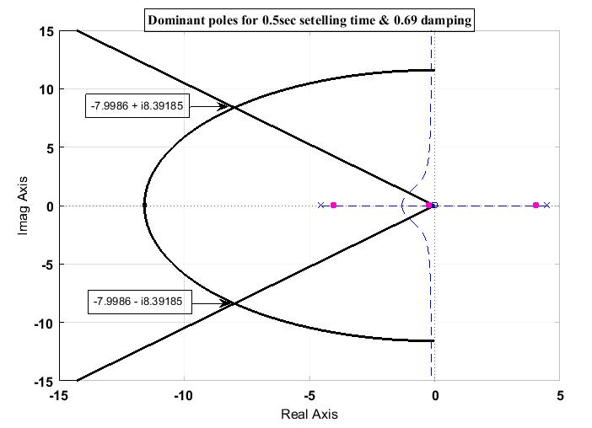

Figure 4‑1 Dominant poles placement for design specification

Fig 4-1 shows the position of dominant pols for desire system performance as overshoot less than 5% and settling time less then 0.5sec.

## Compensation design

In order to obtain the desired performance of the system, we use compensating networks. Compensating networks are applied to the system in the form of feed forward path gain adjustment. Compensate a unstable system to make it stable.

System transfer function:

Note in this transfer function that there three poles and one zero. Since due to one pole lie in the right half-plane, the system is unstable.

Due to presence of the zero at the origin, the section of the root locus in the right half-plane cannot be drawn into the left half-plane in order to achieve stability.

If we use PD controller to achieve stability i.e. the lead compensator where zero leads the pole; placing the zero in the right half-plane only reinforces the instability, and placing it in the left half-plane has no effect on the unstable region.

The compensation for the Inverted Pendulum System can be designed using any of the Following control analysis and design techniques. These are:

* ROOT-LOCUS Method
* BODE-PLOTS
* NYQUIST Diagrams
* NICHOLS Charts

Out of these techniques, the Root-Locus technique is time domain technique, whereas the later three are frequency domain techniques. We have used the root-locus techniques because they permit accurate computation of the time-domain response in addition to yielding readily available frequency response information.

### Why Root Locus?

There exist many tools to an engineer designing a control system. Whychoose to design for stability using the root locus? There are several reasons that make the root locus apt to selecting the type of controller to be utilized: it is a simple and visual design tool that is quickly and easily generated; the stability of the system is reliably represented; and an idea of how changes to the controller affect the overall stability of the system can be quickly perceived.

### Root Locus of Uncompensated System

The SISO Design Tool is a graphical user interfacing (GUI) that facilitates the design of compensators for single input, single output feedback loops. The root locus of characteristics equation 1 + is shown in Fig 4-2. It is the locus of open loop poles such as the value of varies from 0 to infinity in the close loop characteristics equation with unity feedback as

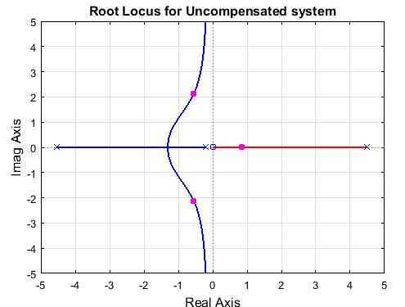

Figure 4‑2 Root locus for uncompensated system

The system analysis indicates that using only the gain compensation in closed loop cannot control the IP. **RESHAPING OF THE SYSTEM ROOT LOCUS** is necessary so that for certain range of gains, the system has all its roots in the left half plane (stable region) of the s-plane.

That is, as the given system is unstable for all values of gain, so the root locus must be reshaped so that the part of each branch falls in the left half s-plane, thereby making the system stable.

Also the desired performance specifications established for the system must be achieved.

### Necessity of the Integrator

From the root locus shaping described in Section **…,** it is apparent that the system cannot be made stable using PD control, as the lossless system can be. In fact, application of any one real or complex zero or pole is unable to draw the root locus into the stable region. This is because of the zero; as it serves as a sink, it is impossible to draw the root locus away from it without forcing the segment associated with the right half-plane pole to remain unstable.

The next tactic available to the designer is to cancel the zero at the origin using an integrator. In design practice, canceling zeroes and poles is typically a poor decision. This is because in application to real systems, poles and zeroes can drift due to changes in the system and its environment. If the canceling singularity drifts away from the canceled, the undesirable system dynamics can return.

However, in this case, the zero is at the origin, and is unlikely to drift due to the fact that the losses are modeled as viscous damping and purely dissipative. This means that application of a pole to the origin in order to cancel the offending zero is an acceptable design decision, and in fact the simplest way to draw the root locus into the left hand-plane.

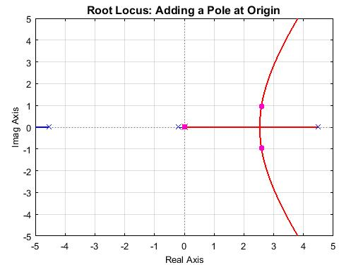

Figure 4‑3 Shape of root locus after adding a integrator in the system

**Limitations of root locus:**

The numerical computations required to tune system performance to the desired level can require iteration, and it is difficult to numerically optimize the system response via root locus design.

COMPENSATION GOALS

The desired TRANSIENT response for the system has following characteristics:

* **Transient (settling) time** of **0.5 sec**
* **Overshoot** should be **< 5%**, it implies that
* The **damping ratio > 0.69**

The desired STEADY-STATE response for the system has following characteristics:

* **Steady-state error** must be **zero**.

### Lead-Lag Compensator Design

The lead-lag compensator is often applied to alter an undesired frequency response of a system. In this case, it is applied as a variation on proportional-integral-derivative (PID) control. The advantage in this situation of using the lead-lag controller is that all poles and zeros can be placed on the real axis, and oscillation can thus be eliminated from the system. In addition, the extra pole gives the system another dimension that can be tuned, and a greater control of the system response can be obtained.

Due to the presence of the zero at the origin, one pole was selected to be at the origin, canceling it and serving as the integrator. This serves as the root of the lag compensator.

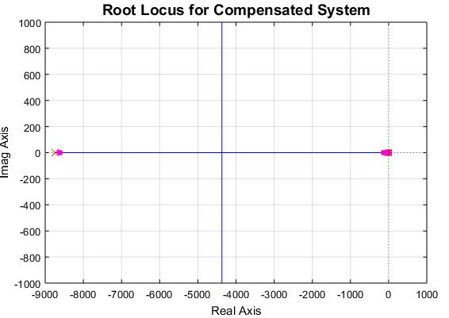

Figure 4‑4 Root locus of compensated system

The zero of lag compensator was then placed to the left of this system pole(-0.199) at -0.6697. The benefit of this placement is this placement is that this zero can control the bandwidth of the system independently. Similarly the pole of lead compensator is placed left to the system pole(-4.5447) at -6.9448. and the pole of lead compensator place according to the controller design specification by using trial and error method with SISO tool.

Finally from Fig 4-4, the close loop pole lies on the real axis of left half of S-plane to get the desire performance of the system.

### Simulation of Compensated System

After placement of these poles, it was determined for the physical system at hand that the following transfer function created an accepted system response:

#### Step Response of Compensated System

In Fig. 4-5, This simulation model shows the step response of the Compensated Inverted Pendulum system. It shows that system become stable as the output stabilizes for certain value.

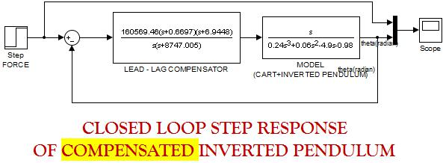

Figure 4‑5 Simulation for step response of compensated system

The step response of the lag – lead compensated system is shown in Fig 4-6. The Dc gain of close loop compensated IP system is 160569.46. The percentage Overshoot is less than 5% and settling time is also less than 0.5sec.

This model was thus deemed acceptable for application to the system, but other potential controller were also investigated.

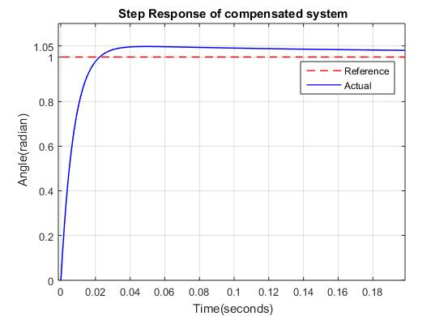

Figure 4‑6 Step Response of Compensated system

#### Impulse Response of Compensated System

In Fig. 4-7, This simulation model shows the impulse response of the Compensated Inverted Pendulum system.

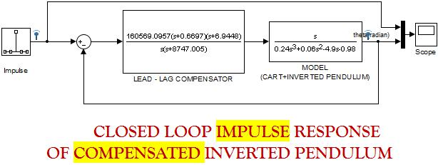

Figure 4‑7 Impulse Response of compensated system

The impulse response of the compensated system is shown in the Fig 4-8. The response of the system is very fast. Settling time is very small i.e. 0.06sec.

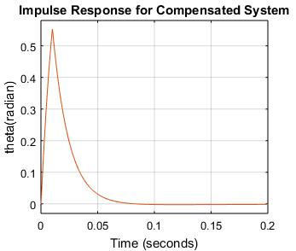

Figure 4‑8 Impulse Response of compensated system

## Full State Feedback Design

Though a state feedback controller is capable to handling multiple input and multiple output systems, for IP control, only one input, force(F), and two outputs, angle() and linear position(x) are to controlled. The measurement of the states must be sufficiently accurate and noise free, or the system response deteriorates.

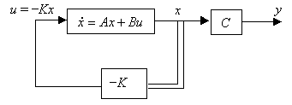

Figure 4‑9 Full state feedback controller schematic

### Achieving Stability by Pole placement method

The main objective of the pole placement is that the closed loop poles should lie at which are their ‘desired locations’. It is assumed that all state variables are measurable and are available for feedback.

Closed loop system dynamics

.

By choosing an appropriate gain matrix for state feedback, it is possible to force the system to have closed-loop poles at the desired locations, provided that the original system is completely state controllable.

The control vector is designed in the following state feedback form

.

Where is a constant state feedback gain matrix.

This leads to the following closed loop system

where

.

|  |  |
| --- | --- |
| . | (4.1) |

The control-law design then consists of picking the gains so that the roots of eqn(4.1) are at desirable locations. The stability and the transient response characteristics are determined by the Eigen values of the matrix (A−Bk). In equation the matrix k is not unique for a given system, but it depends on desired closed loop pole locations (which determine the speed and damping of the response).

This method depends on the performance criteria, such as rise time, settling time, and overshoot used in the design.

#### Design procedures for pole placement

1. Using control design specification from section **4.1** to locate dominant poles.
2. Then placing rest of poles so they are “much faster” than the dominant second order behavior.

* Typically, keeping the same damped frequency and then moving the real part to make them faster than the real part of the dominant poles so that the transient response of the real poles of the system will decay exponentially to insignificance at the settling time generated by the second order pair.
* While taking care of moving the poles too far to the left because it takes a lot of control effect (needs large actuating signal).

1. Simulate system with full state feedback as put the desire pole by using ‘place’ command of MATLAB as shown in Fig 4-10.

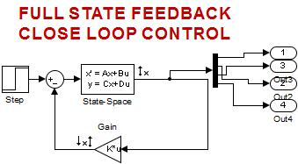

Figure 4‑10 Simulation for Full state feedback using Pole Placement

Using MATLAB software, the following are the gain vectors for different sets of desired poles.

→ **Test-1**

By making the remaining poles times faster than the real part of the dominant poles.

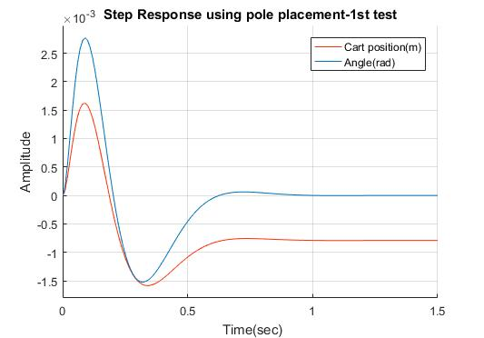

Figure 4‑11 Step Response using pole placement – 1st test

→ **Test-2**

]

=

By making the remaining poles times faster than the real part of the dominant poles.

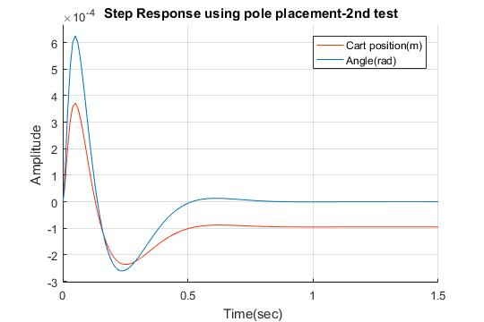

Figure 4‑12 Step Response using pole placement – 2nd test

→ **Test – 3**

=

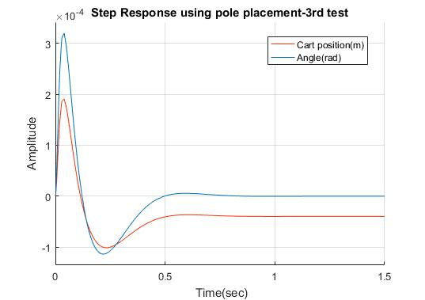

Figure 4‑13 Step Response using pole placement – 3rd test

**Note:** As can be seen from the respective plots of the system step response for each calculated gain vectors as per the desired pole locations, System design requirements are satisfied in all the three tests. And, the system response tends to be faster when the real poles go farther to the left from the real part of the dominant poles. A more faster response can be found by moving the real poles deeper in to the left half side of the s-plane, but it requires a larger actuating signal which in turn brings larger control effort.

# Experimental Determination

*[Hardware implementation for ‘INVERTED PENDULUM ON CART’ is explained in this chapter. Experimental analysis and its results are discuss in this chapter]*

## Hardware Setup Explanation

To attempt to make the task of inverted pendulum the robot is little bit easier, the hardware is designed to mimic the idealized model describe in Fig 5-1.

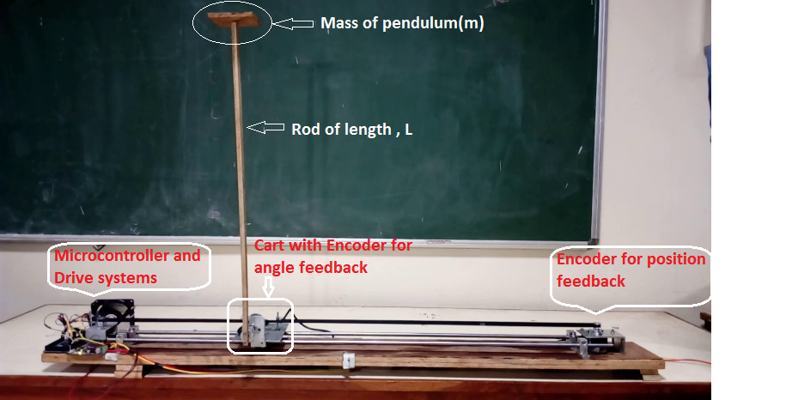

Figure 5‑1 Image of hardware setup of Inverted Pendulum

Experimental setup for Inverted Pendulum consists of PC with MATLAB, Arduino Mega controller, DC motor as an actuator, Encoders as Angle sensor and Distance Sensor, pendent pendulum kept on massless rod, track with a length of 1 m and a cart setup on the linear track.

Cart and pendulum system is the main thing of this setup. The cart is driven by the belt-pulley mechanism which is driven by the DC motor. The cart is driven by the DC motor according to the control voltage.

### Body

The body of the robot consists of two stainless rod 8mm diameter for setting of horizontal track, four horizontal shaft support two for each SS rod on the plywood base, a cart placed on the platform made by two CNC bearing passing through the rods. Cart-inverted pendulum system is driven through the belt-pulley mechanism which is actuated by DC motor.

### Controller

The Arduino Mega 2560 is a controller board based on the Atmega2560. This is used as the ‘brain’ of the inverted pendulum system. The controller consists of a powerful 8-Bit microcontroller running at 16 MHz, there is 128 KB of flash memory, 8 KB of SRAM and 4 KB of EEPROM. This allows relatively large and computing intensive programs to be executed quite easily. The programming language used in this is C, C++ and assembly language.

### Drive Systems

The drive system consisted of an independent DC Johnson gearless motor of 18000 rpm mounted with pulley along one side. Belt is attached with the pulley for driving the cart on the linear track. The motor nominal voltage is 12 V and exerts 18 kg-cm of load torque. The full load current is about 2A.

Table 4 Motor specification

|  |  |
| --- | --- |
| Rated voltage | 12V |
| Rated torque | 18 kg-cm |
| Rated speed | 18000 rpm |
| Rated current | 2A |
| No load current | 1.6A |
| Stall current | 8A |

So we need a good motor driver to control the speed and direction from a microcontroller. MD13S is a great motor driver where S stands for Surface Mount Device. MD13S is able to output current to 30A max. And the continuous current is at 13A (in room temperature of 25 degree C). It has bi-directional control for 1 brushed DC motor and support motor voltage range from 6V to 30V. And the logic level input varies from 3.3V to 5V and the speed control PWM frequency is up to 20 KHz.

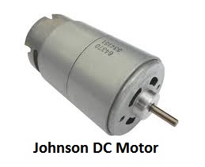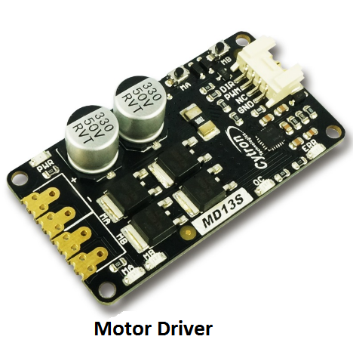

Figure 5‑2 Image of Motor and Motor driver

### Encoders

This is an 0.15 degree resolution optical encoder with quadrature outputs for increment and decrement counting. It will give 2400 transitions per rotation between outputs A and B. A quadrature decoder is required to convert the pulses to an up or down count. It need power supply of 5V and its current consumption is less than or equal to 60mA.

So here in our project we have used two encoders. One encoder is measuring the tilt angle of the inverted pendulum balanced on cart and second encoder is used for measuring the position of the cart on the linear cart. So we need not to use the limit switch for effective cart driving on the limited track. Second encoder is proving us the position of the cart on the linear track so we can limit our cart to its maximum position.

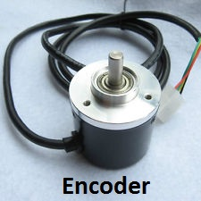

Figure 5‑3 Image of quadrature Encoder

## Controller: Classical PID Controller

The goal is to create a PID controller for an Inverted pendulum built out from scratch. It is using two rotational quadrature encoders to determine the linear position of the cart and the angle of the pendulum. The motor is driven by a citron motor driver by an external power supply.

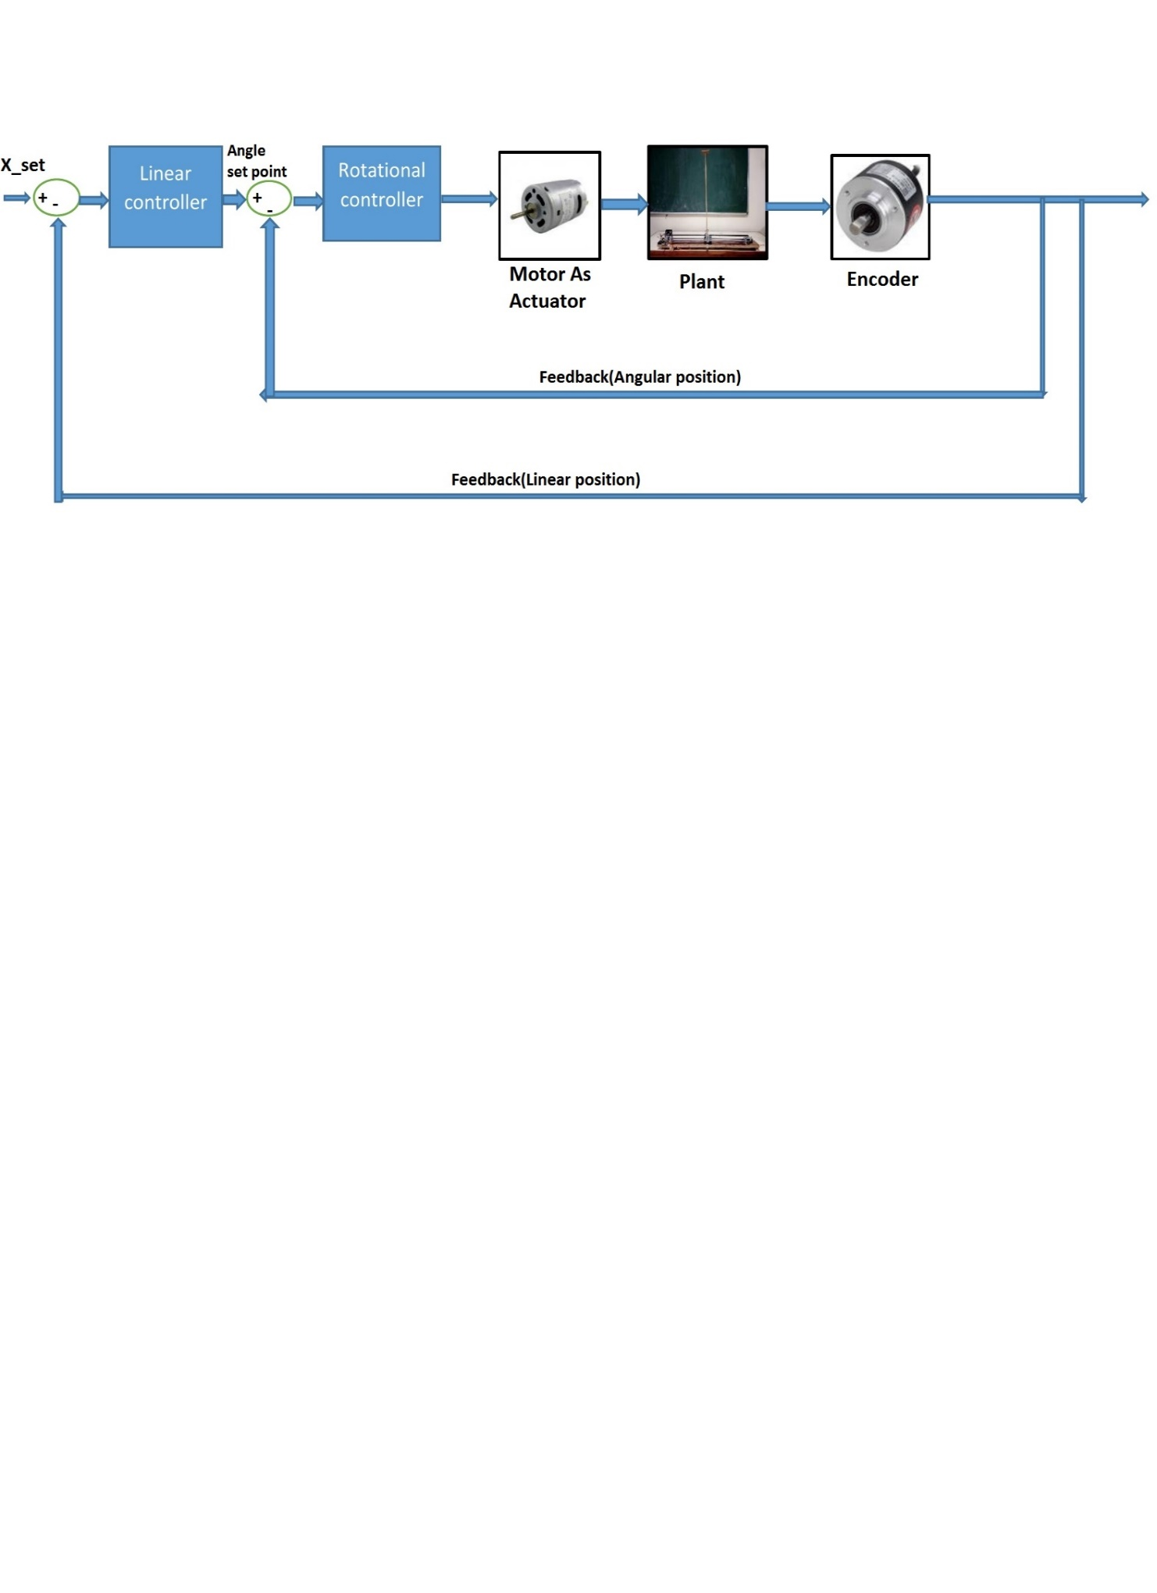

Figure 5‑4 Block diagram of Control scheme with PID controller

In Fig 5-4, the block diagram shows the flow of logic to control the inverted pendulum system. We have implemented closed loop PID controller on the hardware set up of the system. The basic structure of the feedback control system is described here. The angle sensor reading is subtracted from the reference angle to produce the error. This error is used to calculate the motor control parameters using PID algorithm. The motor control is then sent to the device. The reference angle is the only input to the system, and the feedback control uses the error in angle from the reference and calculate the motor output.

But here we have applied two PID algorithm in cascade. PID output of the linear controller outputs the rotational set point. Thus if we want to stabilized the cart- inverted pendulum system around a fixed linear set point, then it will output the rotational set point to the inner loop. Thus cart- inverted pendulum system will try to balance around the given position on the linear track.

**PID Explanation:**

Here’s the PID equation is written:

Output =

Where:

This is just the equation of PID controller. If we are going to implement this on the hardware set up then we need to address a few things:

1. **Sample Time** – The PID algorithm functions best if it is evaluated at a regular interval. If the algorithm is aware of this interval, we can also simplify some of the internal math.
2. **Derivative Kick** – Not the biggest deal, but easy to get rid of, so we are going to do just that.
3. **On-The-Fly Tuning Changes** – A good PID algorithm is one where tuning parameters can be changed without jolting the internal workings.
4. **Reset Windup Migration** – We will go into what Reset Windup is, and implement a solution with side benefits.
5. **On/off (Auto/ Manual)** – In most applications, there is a desire to sometimes turn off the PID controller and adjust the output by hand, without the controller interfacing.
6. **Initialization** – When the controller first turns on, we want a “bumpless transfer,” That is, we do not want the output to suddenly jerk to some new value.
7. **Controller Direction** – This last one is not a change in the name of robustness per se. It is designed to ensure that the user enters tuning parameters with the correct sign.

## Discussion of Hardware Result

In Fig 5-5, It is the plot of the PID response of angular position, Experimental data recorded using Serial communication between MATLAB and Microcontroller based data acquisition.

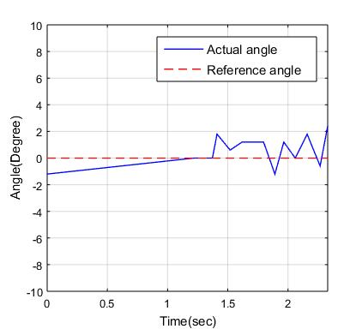

Figure 5‑5 PID Response of angular position

The Inverted Pendulum was given an initial condition as angular position, as indicated by an initial 1 degree magnitude of pendulum’s angular displacement.

As is shown in the plot, the **settling time** of the system is 0.5 seconds, but the Peak Overshoot is more then 5%, this error occur in the system because of the noise in the feedback signal as noise in the encoder sensing.

# CONCLUSION & FURTHER WORK

Modeling of an inverted pendulum shows that the system is unstable without a controller. Results of applying state feedback controllers or designing a lead lag compensator using the technique of root locus shaping show that the system can be stabilized. The first was a lead-lag controller. The design of this controller was such that the dominant poles were on the real axis to prevent low-frequency oscillation. The response and required control effort of the lead-lag compensated system to a disturbance torque were calculated and deemed acceptable, except for the presence of significant high-frequency oscillation. To create a more satisfactory system response, state feedback control was implemented.

Using pole placement, the unstable pole was moved to the left half-plane, and the pole near the origin that limited the speed of system response was moved to a higher natural frequency. The system response for the state feedback system was the most satisfactory of the three, as the system quickly rejected disturbance torques with no oscillation whatsoever.

Once the controller had been determined on the simulation basis, now it’s time to implement that on hardware form. A cart on linear track was driven by belt-pulley system which is actuated by DC motor which are incorporated with encoders as feedback sensor. Software is based on the PID controller and its response is studied using MATLAB.

# REFERENCE LIST

1. Anderson, Charles W. "Learning to control an inverted pendulum with connectionist networks." In *American Control Conference, 1988*, pp. 2294-2298. IEEE, 1988.
2. Armstrong-Hélouvry, Brian, Pierre Dupont, and Carlos Canudas De Wit. "A survey of models, analysis tools and compensation methods for the control of machines with friction." *Automatica* 30, no. 7 (1994): 1083-1138.
3. Åström, Karl Johan, and Katsuhisa Furuta. "Swinging up a pendulum by energy control." *Automatica* 36, no. 2 (2000): 287-295.
4. Bogdanoff, J. L., and S. J. Citron. "Experiments with an inverted pendulum subject to random parametric excitation." *The Journal of the Acoustical Society of America* 38, no. 3 (1965): 447-452.
5. Blitzer, L., “Inverted pendulum” vol. 33, no. 12, pp. 1076_1078, 1965.
6. Bugeja, Marvin. "Non-linear swing-up and stabilizing control of an inverted pendulum system." In *EUROCON 2003. Computer as a Tool. The IEEE Region 8*, vol. 2, pp. 437-441. IEEE, 2003.
7. Chang, L-H., and A-C. Lee. "Design of nonlinear controller for bi-axial inverted pendulum system." *IET Control Theory & Applications* 1, no. 4 (2007): 979-986.
8. Dunnigan, Matthew W. "Enhancing state-space control teaching with a computer-based assignment." *IEEE Transactions on Education* 44, no. 2 (2001): 129-136.
9. Eltohamy, Khaled Gamal, and C. Y. Kuo. "Real time stabilisation of a triple link inverted pendulum using single control input." *IEE Proceedings-Control Theory and Applications* 144, no. 5 (1997): 498-504.
10. F. L. Lewis, “Linear Quadratic Regulator (LQR) State Feedback Design”, Lecture notes in Dept. Elect. Engineering, University of Texas, Arlington, Oct 2008.
11. Fang, Lei, Wei Ji Chen, and Sek Un Cheang. "Friction compensation for a double inverted pendulum." In *Control Applications, 2001.(CCA'01). Proceedings of the 2001 IEEE International Conference on*, pp. 908-913. IEEE, 2001.
12. Gawthrop, Peter J., and Liuping Wang. "Intermittent predictive control of an inverted pendulum." *Control Engineering Practice* 14, no. 11 (2006): 1347-1356.
13. Henders, M. G., and A. C. Soudack. "Dynamics and stability state-space of a controlled inverted pendulum." *International journal of non-linear mechanics*31, no. 2 (1996): 215-227.
14. Hung, Chuan-Chang, and R. Benito Fernandez. "Comparative analysis of control design techniques for a cart-inverted-pendulum in real-time implementation." In *American Control Conference, 1993*, pp. 1870-1874. IEEE, 1993.
15. Lowenstern, E. R. "XXXIX. The stabilizing effect of imposed oscillations of high frequency on a dynamical system." *The London, Edinburgh, and Dublin Philosophical Magazine and Journal of Science* 13, no. 84 (1932): 458-486.
16. Lozano, Rogelio, Isabelle Fantoni, and Dan J. Block. "Stabilization of the inverted pendulum around its homoclinic orbit." *Systems & control letters* 40, no. 3 (2000): 197-204.
17. Medrano-Cersa, G. A. "Robust computer control of an inverted pendulum." *IEEE Control Systems* 19, no. 3 (1999): 58-67.
18. Miles, John. "Directly forced oscillations of an inverted pendulum." *Physics Letters A* 133, no. 6 (1988): 295-297.
19. Ness, Douglas J. "Small oscillations of a stabilized, inverted pendulum." *American Journal of Physics* 35, no. 10 (1967): 964-967.
20. Phelps III, F. M., and J. H. Hunter Jr. "An analytical solution of the inverted pendulum." *American Journal of Physics* 33, no. 4 (1965): 285-295.
21. Pippard, A. B., “The inverted pendulum” European Journal of Physics, vol. 8, no. 3, p. 203, 1987.
22. Rozenblat, G. H. "Optimal parametric stabilization of an inverted pendulum." *Journal of Applied Mathematics and Mechanics* 45, no. 1 (1981): 45-50.
23. Sahba, M. "Computer-aided design of feedback controllers for nonlinear systems with applications to control of a double-inverted pendulum." In *IEE Proceedings D-Control Theory and Applications*, vol. 130, no. 6, pp. 350-358. IET, 1983.
24. Stephenson, A. "Memoirs and Proceedings of the Manchester Literary and Philosophical Society 52, 1–10." *On a new type of dynamic stability* (1908).
25. Stephenson, Andrew. "LXXI. On induced stability." *The London, Edinburgh, and Dublin Philosophical Magazine and Journal of Science* 17, no. 101 (1909): 765-766.
26. Wei, Qifeng, Wijesuriya P. Dayawansa, and William S. Levine. "Nonlinear controller for an inverted pendulum having restricted travel." *Automatica* 31, no. 6 (1995): 841-850.
27. Yamakawa, Takeshi. "Stabilization of an inverted pendulum by a high-speed fuzzy logic controller hardware system." *Fuzzy sets and Systems* 32, no. 2 (1989): 161-180.
28. Yoshida, Kazunobu. "Swing-up control of an inverted pendulum by energy-based methods." In *American Control Conference, 1999. Proceedings of the 1999*, vol. 6, pp. 4045-4047. IEEE, 1999.